

GASABO DISTRICT COMPREHENSIVE ASSESSMENT
FOR 2ND TERM, ACADEMIC YEAR 2022-2023.
TRADES: (SOD, NET).
RTQF LEVEL: IV
SUBJECT: APPLY ALGORITHM FUNDAMENTALS
DURATION: 3hrs 0n …….. / ……./ 2023
MARKING GUIDES
INSTRUCTION TO CANDIDATES:
- This question paper consits of THRE sections A, B and C
- Answer all questions in section A ( 50marks).
- Answer only Three questions in section B ( 30matks).
- Answer only One question in sectio C ( 15marks).
- Use only blue or black pen for answering.
- Mathematical instruments are allowed where it is necessary.
Note: Results for any candidate who is caught in examination malpractices are nullified.
SECTION A: ATTEMPT ALL QUESTIONS IN SECTION A /50 MARKS
QUESTION 1: /5marks
a. How can we define an array? Defend your answer
- The Array shows a hierarchical structure.
- Arrays are immutable.
- Container that stores the elements of similar types
- The Array is not a data structure
b. Why do we need to use arrays?
Solution:
a. C. Container that stores the elements of similar types
b. Arrays are used when we want to store data in large quantities.
References:LU3 Describe data structure, LO 3.2: Describe array in line with programming Curriculum version (level): RTQF LEVEL: 4, page 106, year 2019
QUESTION 2: By using flowcharts, give the syntaxes of For, Do while and while loops. /5marks
Solution:
The syntax of for

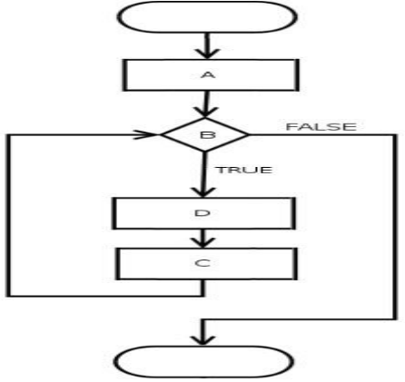
The syntax of do while
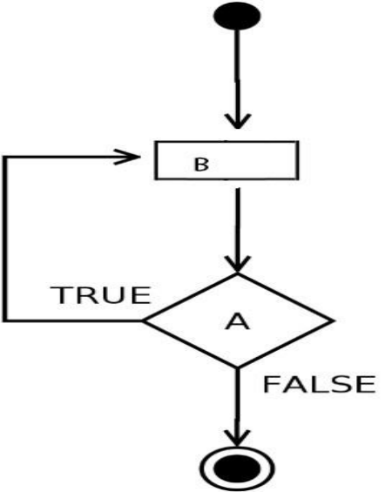
The syntax of while
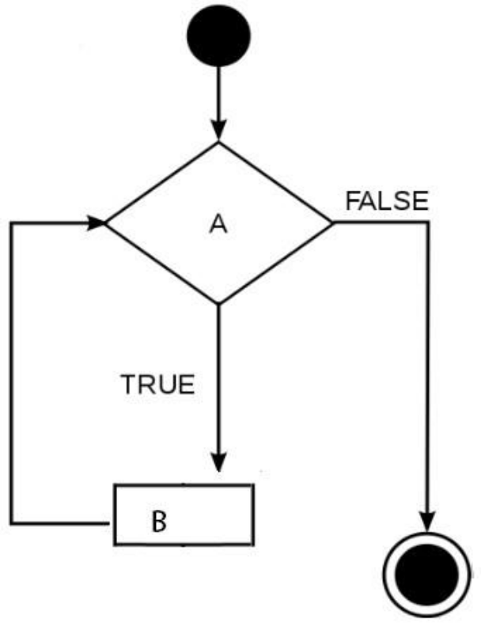

References: LU2.Apply programming structures, iterative constructs and
structured programming, LO 2.3: Use iterative statements in programming
Curriculum version (level): RTQF LEVEL: 4, page 80-83, year 2019
QUESTION 3: Answer by true (T) or False (F) /5marks
- Ambiguous: Algorithm should not be clear and ambiguous. Each of its steps (or phases), and their inputs/outputs should not be clear and must lead to only one meaning.
- Input: An algorithm should not have 0 or more well-defined inputs.
- Output: An algorithm should have 1 or more well-defined outputs, and should match the desired output.
- Finiteness: Algorithms must not terminate after a finite number of steps.
- Dependent: An algorithm should not have step-by-step directions, which should be dependent of any programming code.
Solution:
a) False
b) False
c) True
d) False
e) False
References:LU1 Describe basic concept of algorithm, LO1.2 Describe the key concepts of algorithm in programming Curriculum version (level): RTQF LEVEL: 4, page 19, year 2019

QUESTION 4: Different algorithms play different roles in programming.
You only need to define your problem then select the right
Algorithm to use. Outline three (3) main types of Algorithm.
/5marks
Solution:
The algorithm and flowchart are classified into three types of control structures.
1. Sequence
2. Branching (Selection)
3. Loop (Repetition)
References:LU2. Apply programming structures, iterative constructs and structured programming, LO2.3: Use iterative statements in programming Curriculum version (level): RTQF LEVEL: 4, page 29, year 2019

QUESTION 5: Write an algorithm which receives a number and calculate its
Factorial. (By Using For-loop) /5marks

Solution: or
Start step 1: start
Var i, n, f=1 as int step 2: read a number n
Write (“Enter a number”) step 3: initialize variable i=1, f=1
Read n step 4: if i<=n go to step 5 otherwise
For(i=1; i<=n; i++) go to step 8
f= f *i step 5: calculate f=f *i
endfor step 6: increment the i by 1(i=i+1) and
write f go to step 4
end step 7: print f
step 8: stop

References: LU2.Apply programming structures, iterative constructs and
structured programming, LO 2.3: Use iterative statements in programming
Curriculum version (level): RTQF LEVEL: 4, page 80-87, year 2019
QUESTION 6: /5marks
- What is a switch statement?
- Give the syntax of switch statement.
Solution:
a)A sequential statement or switch case statement or simply switch statement tests the value of a variable and compares it with multiple cases.
Once the case match is found, a block of statements associated with that particular case is executed
b) A general syntax of how switch-case is implemented is as follows:
switch( expression )
{
case value-1:
Block-1;
Break;
case value-2:
Block-2;
Break;
case value-n:
Block-n;
Break;
default:
Block-1;
Break;
}
Statement-x;
References:LU2 Apply programming structures, iterative constructs and structured programming, LO 2.2: Use sequential statements in programming Curriculum version (level): RTQF LEVEL: 4, page 72, year 2019

QUESTION 7: Discuss the characteristics of an algorithm. /5marks

Solution:
• Unambiguous − Algorithm should be clear and unambiguous. Each of its steps (or phases), and their inputs/outputs should be clear and must lead to only one meaning.
• Input − An algorithm should have 0 or more well-defined inputs.
• Output − An algorithm should have 1 or more well-defined outputs, and should match the desired output.
• Finiteness − Algorithms must terminate after a finite number of steps.
• Feasibility − Should be feasible with the available resources.
• Independent − An algorithm should have step-by-step directions, which should be independent of any programming code.
References:LU1 Describe basic concept of algorithm, LO1.2 Describe the key concepts of algorithm in programming Curriculum version (level): RTQF LEVEL: 4, page 19, year 2019

QUESTION 8: Define the following terms: /2.5marks
  - Algorithm
  - Flowchart
  - Variable
  - Loop

Solution:
a) Algorithm refers to a set of rules/instructions that step-by-step define how a work is to be executed upon in order to get the expected results.
b) Flowchart: is the graphical or pictorial representation of an algorithm with the help of different symbols, shapes and arrows in order to demonstrate a process or a program.
c) Variable: A variable is a name assign to a storage area that the program can manipulate. A variable type determines the size and layout of the variable's memory.
d) Loop: is a sequence of instructions that is continually repeated until a certain condition is reached.
References:LU1 Describe basic concept of algorithm, LO1.2 Describe the key concepts of algorithm in programming Curriculum version (level): RTQF LEVEL: 4, page 277, year 2017

QUESTION 9: What is “read” and “write” in algorithm? /5marks

Solution:
A read function is a function which is used for inputs. It helps to receive the value entered by a user and assign it to a variable.
Write function is used for Inputs; it displays the content of a variable OR displays text messages.
References:LU1 Describe basic concept of algorithm, LO1.2 Describe the key concepts of algorithm in programming Curriculum version (level): RTQF LEVEL: 4, page 53-55, year 2019

QUESTION 10: Write a simple algorithm to divide two numbers
( num1 and num2 ) entered by the user. /5marks

Solution:
Start
Var num1, num2, div as int
Write (“Enter two number”)
Read (num1, num2)
If (num2 <> 0 ) then
div = num1/num2
write (“the quotient is:”, div)
else
write (“Cannot divide by zero”)
end if
end
Reference:LU2 Apply programming structures, iterative constructs and structured programming, LO2.1: Use conditional statements in programming Curriculum version (level): RTQF LEVEL: 4, page 60, year 2019
QUESTION 11: A set of rules that step-by-step define how the work is to be executed upon
in order to get the expected result is known as………………….
/2.5marks

Solution:

Algorithm

References:LU1 Describe basic concept of algorithm, LO1.2 Describe the key concepts of algorithm in programming Curriculum version (level): RTQF LEVEL: 4, page 3, year 2019

QUESTION 12: Write an algorithm that solves the first order equation of the form
ax+b=0.
Note: Analyze all cases. /5marks

Solution:

Start
Var a,b,x as int
Write(“enter the coefficient:”)
Read(a,b)
If(a<>0) then
x=-b/a
Write(“the solution is: ”,x)
Else If (B<>0)then
Write(“Impossible solution”)
Else
Write(“Undetermined(all values are solution)”)
End If
End

Reference:LU2 Apply programming structures, iterative constructs and structured programming, LO2.1: Use conditional statements in programming Curriculum version (level): RTQF LEVEL: 4, page 60, year 2019

SECTION B: ATTEMPT 3 QUESTIONS IN SECTION B /30 MARKS

QUESTION 13: Write an algorithm /C program to display the difference of two
entered numbers by the user through the key-body if the first
number is greater than the second. Otherwise it displays their sum. /10marks

Solution:

Start
Var num1, num2, sum, sub as int
Write (“Enter two numbers”)
Read (num1,num2)
If (num1 > num2) then
Sub=num1 – num2
Write(“the difference is:”, sub)
Else
Sum = num1 + num2
Write (“the sum is:”, sum)
End if
End
Reference:LU2 Apply programming structures, iterative constructs and structured programming, LO2.1: Use conditional statements in programming Curriculum version (level): RTQF LEVEL: 4, page 78, year 2019

QUESTION 14: /10marks
a. List any five-logic gate by drawing its symbols.
b. Demonstrate by the truth table the following De Morgan theorems.

Solution:
a) 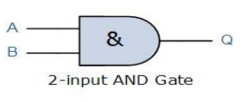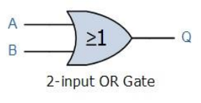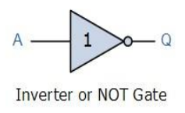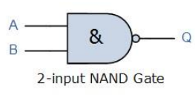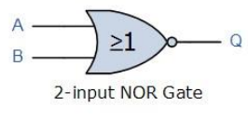
b)
A | b |  |  | a+b | 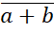 | 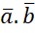
0 | 0 | 1 | 1 | 0 | 1 | 1
0 | 1 | 1 | 0 | 1 | 0 | 0
1 | 0 | 0 | 1 | 1 | 0 | 0
1 | 1 | 0 | 0 | 1 | 0 | 0

QUESTION 15: /10marks
    - Write an algorithm and a flowchart that displays the message if the number given by a user is between 1 and 37.
    - Write an algorithm that allows the user to input a number and display the cube of that number till the user input the negative value.

Solution: a.
Start
Var X as Int
Write(“Enter the number: ”)
Read (X)
If(X>1 AND X<37) then
Write(“The number is between 1 and 37”)
Else
Write(“The number is not between 1 and 37”)
End If
End
b.
Start
Var X as Int
Repeat
Write(“Input the number: ”)
Read(X)
If (X>0) then
Cube=X^3
Write(“The cube of ”,X, “is”, Cube)
End If
Until(X<0)
End
Reference:LU2 Apply programming structures, iterative constructs and structured programming, LO2.1: Use conditional statements in programming Curriculum version (level): RTQF LEVEL: 4, page 78, year 2019

QUESTION 16: Give the C program codes to display: /10marks

[ * ]
[ * ] [ * ]
[ * ] [ * ] [ * ]
[ * ] [ * ] [ * ] [ * ]
[ * ] [ * ] [ * ] [ * ][ * ]

Solution:
#include<stdio.h>
int main( ) {
int i, j, rows;
printf(“Enter the number of rows\n”);
scanf(“%d”, &rows);
for (i = 1; i<=rows; i++){
/* Prints one rows of triangle */
For(j=1; j<=i; j++) {
Printf(“[ * ] ”);
}
Printf(“\n”)
}
Return 0;
}
Reference:LU2 Apply programming structures, iterative constructs and structured programming, LO2.1: Use conditional statements in programming Curriculum version (level): RTQF LEVEL: 4, page 78, year 2019

QUESTION 18: Base conversion
  - Convert 100 110 000 from base 2 to base 8
  - Convert 643 from base 10 to binary
  - Convert 1010 0110 0110 0110 from base 2 to base 16
  - Convert B2A from base 16 to base 10
  - Convert ACB1 from Hexadecimal to Hexadecimal

Solution:
a)100 110 000₂ = 460₈
b) 643₁₀ = 1010000011₂
c) 1010011001100110₂ = A666₁₆
d) B2A₁₆ = 2858₈
e) ACB1₁₆ = ACB1₁₆
References:LU1 Describe basic concept of algorithm, LO1.1 convert number system from one base to another Curriculum version (level): RTQF LEVEL: 4, page 275, year 2017

SECTION C: ATTEMPT ONLY ONE QUESTION IN SECTION C /15 MARKS

QUESTION 27: Draw the flowchart of the following algorithm. /15marks
Step 1: Start
Step 2: Declare variables x,y and z.
Step 3: Read variables x,y and z.
Step 4: If y < x
If z < x
Display x is the largest number.
Else
Display z is the largest number.
Else
If z < y
Display y is the largest number.
Else
Display z is the greatest number.
Step 5: Stop

QUESTION 28: Write an algorithm to solve the quadratic equation of the
form ax^2+bx+c=0 or ax2+bx+c. /15marks

Solution:
Start
Var a,b,c,d,x,x1,x2 as int
Write (“enter the value of quadratic equation”)
Read (a,b,c)
d = b^2 – 4*a*c
if (d<0)then
write(“the equation has no real root”)
else if (d==0) then
write(“the equation has one real root”)
x= -b/(2*a)
write(“the root is x=”, x )
else if (d>0) then
write(“the equation has two real roots”)
x1= (-b + sqrt(d))/(2*a)
x2= (-b – sqrt(d))/(2*a)
write(“the roots are x1= ”, x1 ,”and x2=”, x2)
else
write(“Try again”)
end if
end
Reference: LU2 Apply programming structures, iterative constructs and structured programming, LO2.1: Use conditional statements in programming Curriculum version (level): RTQF LEVEL: 4, page 78, year 2019

